**Keyestudio 8833 Motor Driver Expansion Board**

## **1. Description**

The 8833 board adopts the 8833 motor driver chip driven by two-channel H bridges , and the maximum driving current of a single channel is up to 1.5A, and the terminal of PH2.0 is used.

The IR receiver module is also integrated on the board. Furthermore, there are many PH2.0 expansion interfaces on the board such as ultrasonic interface, analog interface, three-channel tracking interface as well as pin interfaces with Bluetooth and motor driver.

## **2. Specification**

|  |  |
| --- | --- |
| Voltage | USB 5V，DC 6-9V |
| Current | The maximum output is 3A, the actual output is about 1A (it’s 2A when the motor is loaded) |
| Maximum power | * 27W（The actual value is about 9W） |
| Working temperature | -10~50 Degree |
| Dimension | 69*56*18mm |
| Weight | 25.5g |
| Environmental protection attributes | ROHS |

## **Function**

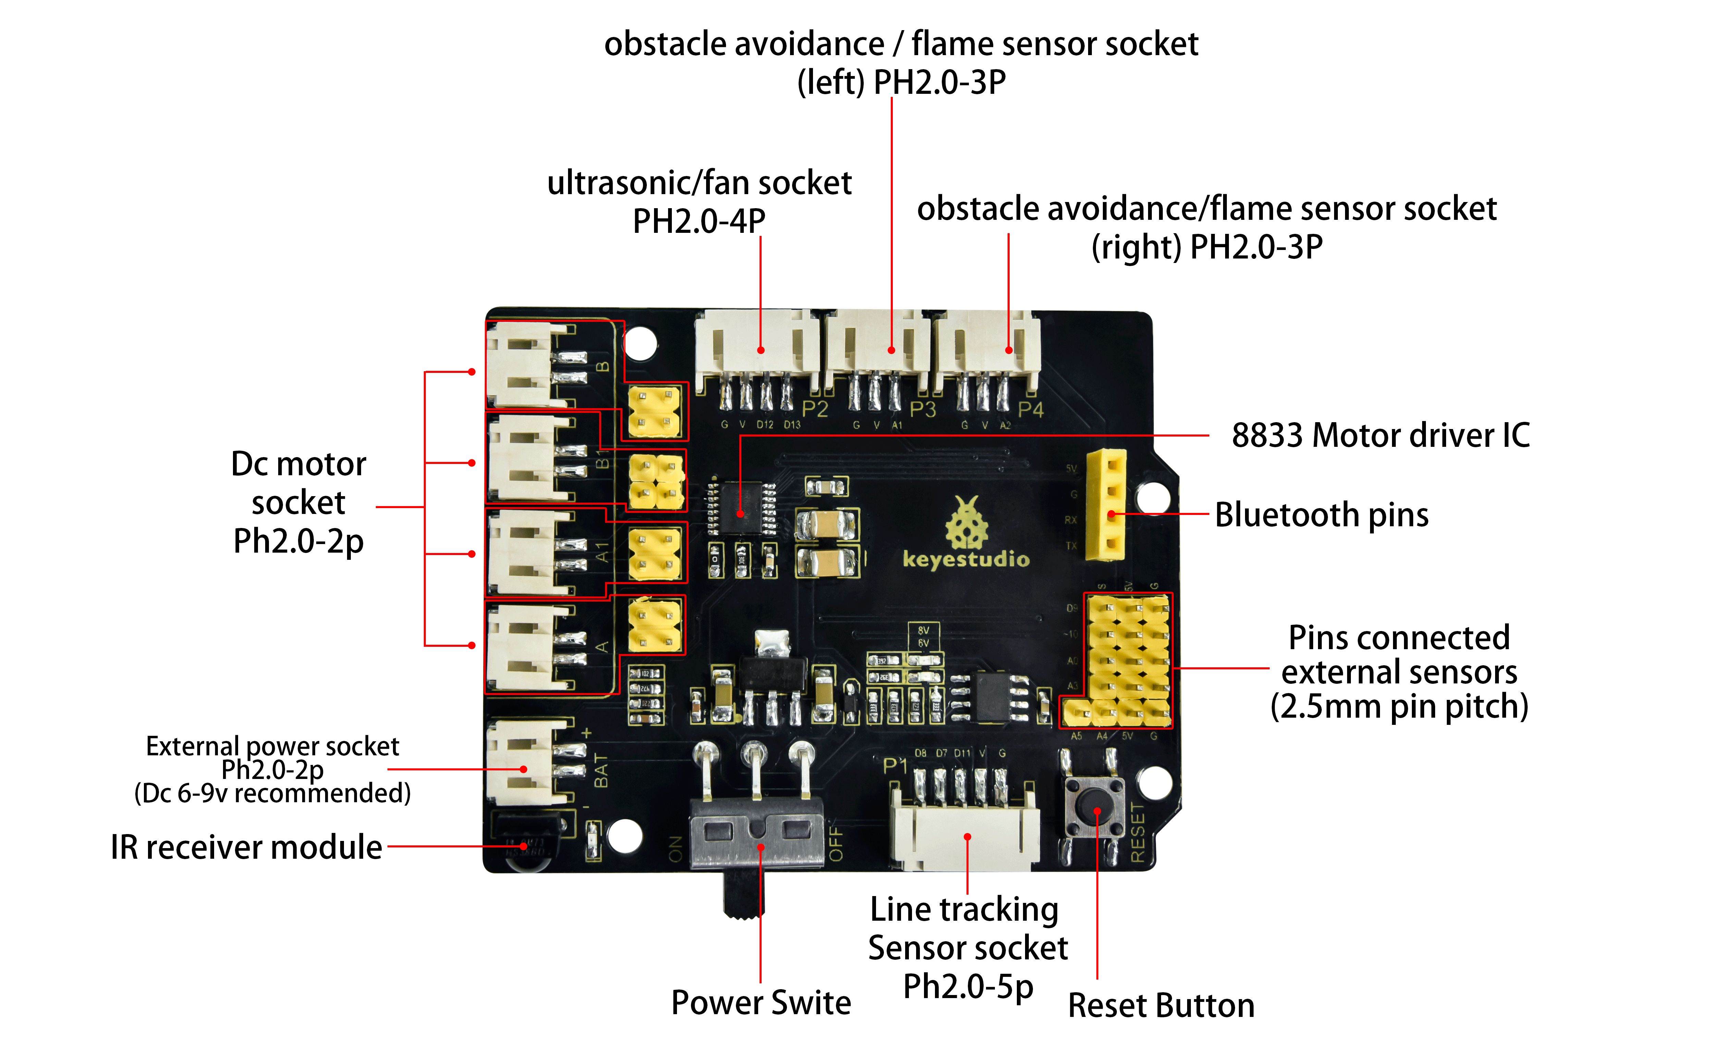

## **Schematic Diagram**

